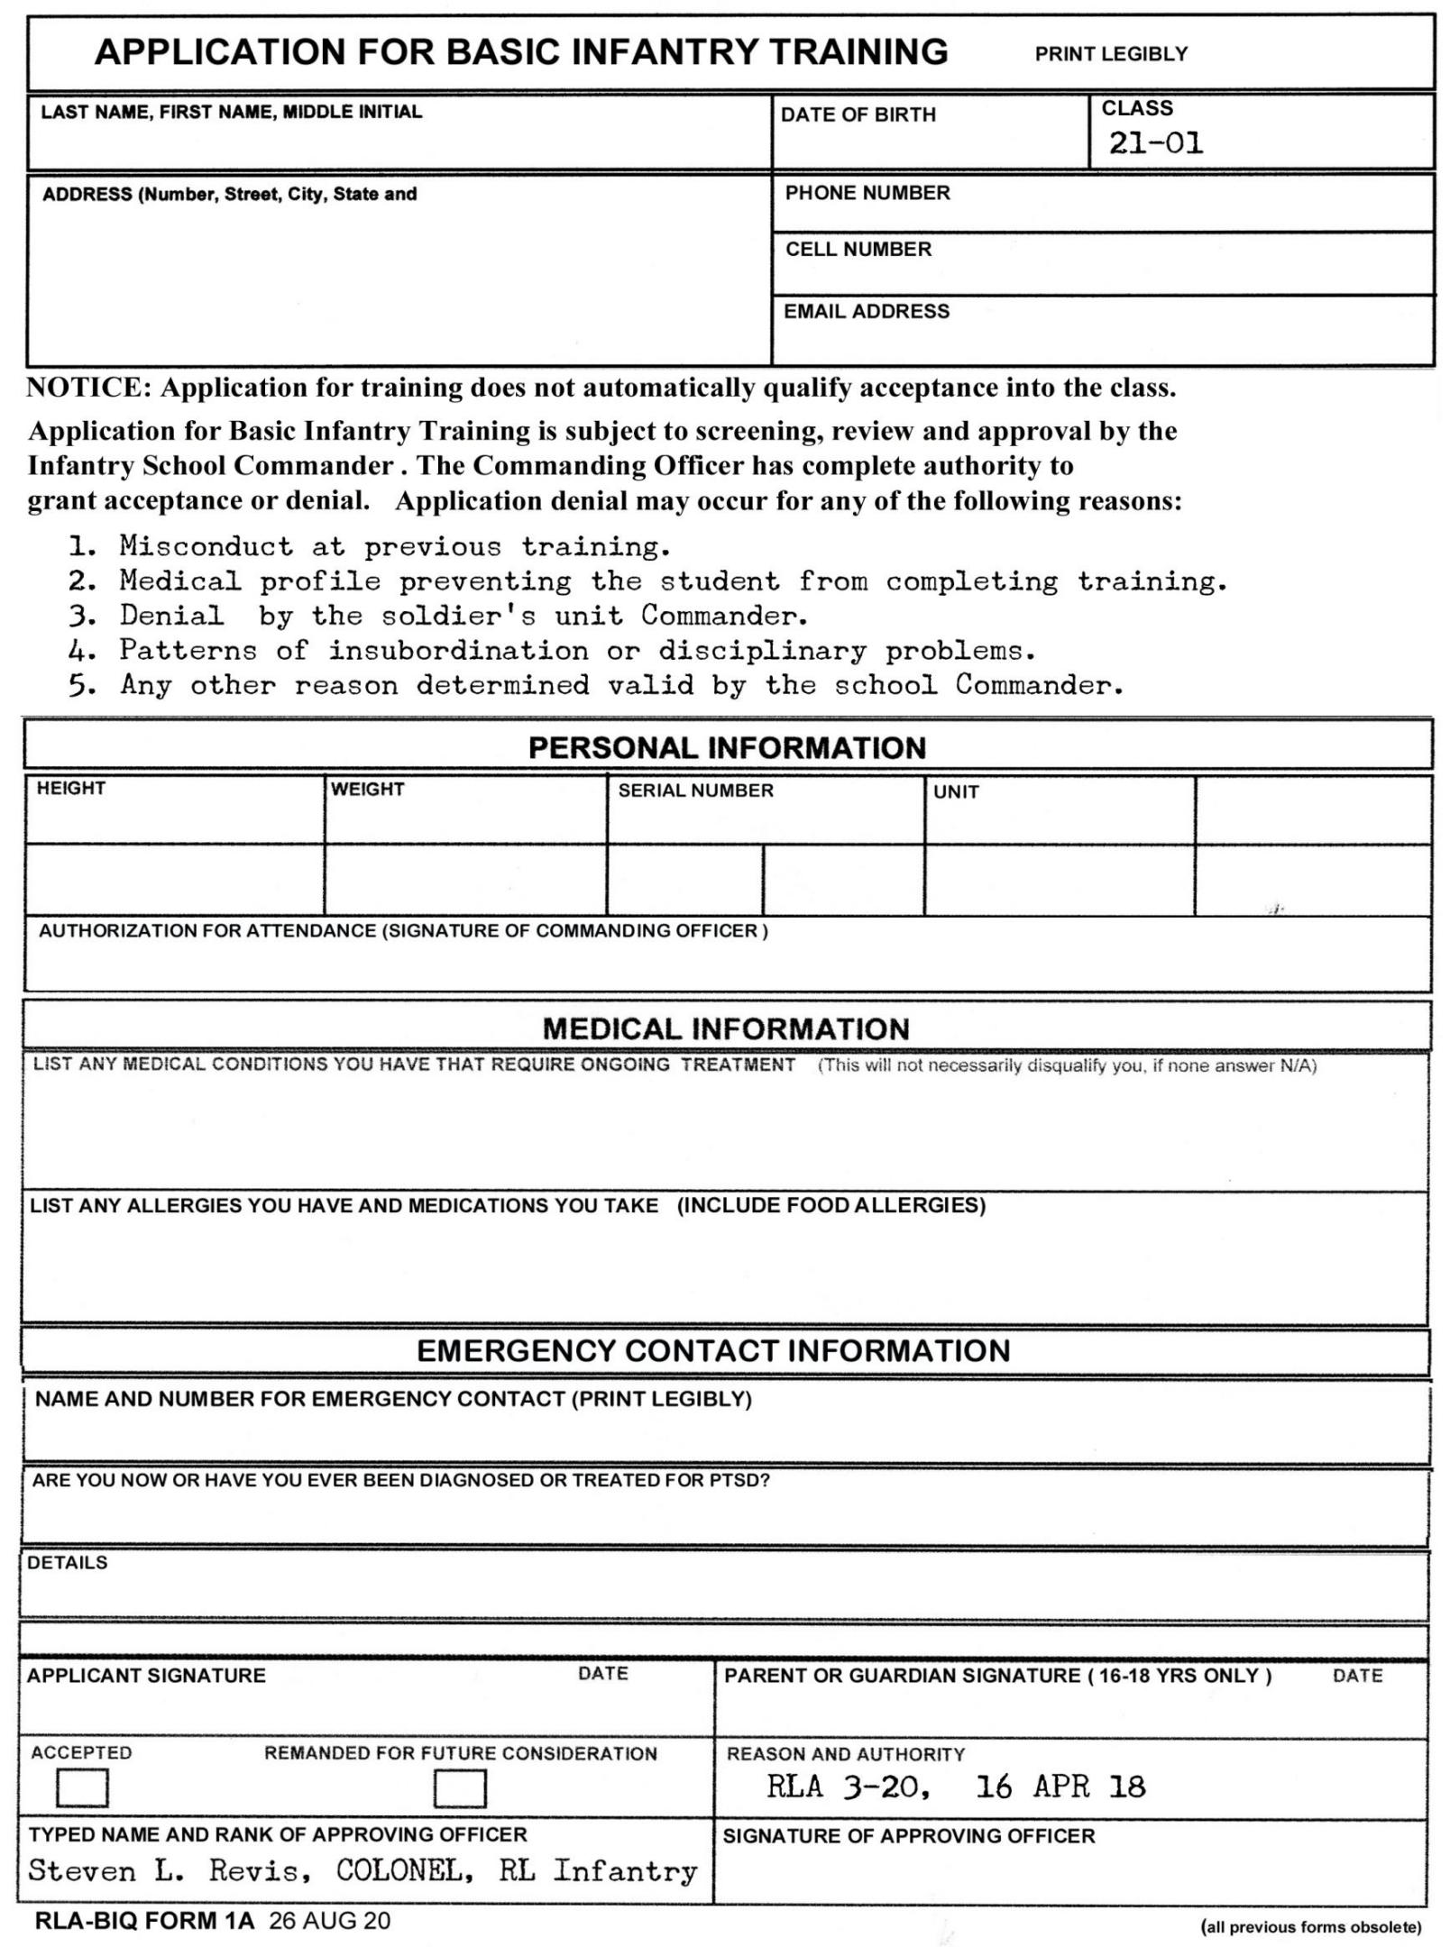

MEDICAL CONDITION FORM

READ CAREFULLY .
THE PURPOSE OF THIS FORM IS TO PROVIDE MEDICAL PERSONNEL WITH INFORMATION OF ANY EXISTING MEDICAL CONDITIONS, WHICH MAY AFFECT MEDICAL CARE AND TREATMENT WHILE YOU ARE UNDER OUR CARE AT TRAINING.
THIS INFORMATION WILL NOT BE VIEWED OR DISCLOSED TO ANYONE OUTSIDE THE SCHOOL MEDICAL STAFF (IAW RLM 15-15, SECURITY CONTROLS AND CLEARANCES).

EMAIL COMPLETED FORM TO COL REVIS AT “LTSTEVEMB@AOL.COM.”
EACH QUESTION IS LISTED HERE FOR A REASON . ANSWER AS COMPLETELY AS POSSIBLE.
NOTE: ANSWER ALL QUESTIONS HONESTLY AND COMPLETELY, TO THOSE THAT DO NOT APPLY, ANSWER N/A (NOT APPLICABLE)
NAME (LAST, FIRST, MI) ______________________________________________ DATE ____________
COURSE: BASIC INFANTRY QUALIFICATION COURSE, CLASS 21-01.
1. Have you ever been a prisoner of war or held in a concentration camp?
Yes_____________ No______________

Are you a documented US Military combat veteran?_______ If yes, year and branch of service_______________________

Have you ever been diagnosed as having PTSD? _____________ Year ______________

- DO YOU HAVE ANY ALLERGIES? (FOOD, MEDICATIONS, INSECT STINGS, ETC). IF YES, LIST THE ALLERGY AND YOUR REACTION. (EX. BEE STING, SHELLFISH, PEANUTS, ETC.)
________________________________________________________________________________________________________

3. ARE YOU CURRENTLY TAKING ANY MEDICATIONS? IF YES, LIST THE MEDICATIONS DOSAGE, AND FRQUENCY. (EX. Claritin 10mg – once daily)
_____________________________________________________________________________________________

_____________________________________________________________________________________________
- HAVE YOU EVER TESTED POSITIVE FOR COVID-19? IF SO, WHEN? (THIS DOES NOT DISQUALIFY YOU. HOWEVER YOU MAY BE REQUIRED TO COMPLETE A SEPARATE QUESTIONAIRE.)
YES ( ) NO ( )

5. ARE YOU CURRENTLY BEING TREATED FOR HYPERTENSION, ASTHMA, HIGH CHOLESTEROL OR STROKE?
____________________________________________________________________________________________________________________________________________________________________________
- HAVE YOU EVER HAD A WEATHER INJURY, HEAT OR COLD? YES( ) NO( )
IF YES, HOT( ) COLD( )
LIST THE EXTENT OF THE INJURY AND YEAR IT OCCURRED.
________________________________________________________________________________________________________
- HAVE YOU HAD SURGERIES OR OTHER SERIOUS INJURIES? (LIST THEM AND WHEN THEY OCCURRED)
________________________________________________________________________________________________________

- LIST ANY IMPORTANT MEDICAL HISTORY YOU FEEL WE SHOULD BE AWARE OF.

______________________________________________________________________________________________________

9. FEMALES ONLY- HAVE YOU BEEN PREGNANT, DELIVERED, OR HAD A PREGNANCY TERMINATED WITHIN THE LAST 180 DAYS ( AR 40-501 PARA 7-10 (e).) YES( ) NO( )

- HAVE YOU EVER BEEN DIAGNOSED OR TREATED FOR AIDS OR ANY OTHER HIGHLY CONTAGIOUS DISEASE? YES ( ) NO ( )

DO YOU HAVE ANY PREVIOUS OR CURRENT BACK INJURIES? YES ( ) NO ( )

- ARE YOU FIT FOR STRENUOUS PHYSICAL DUTY? YES ( ) NO ( )

RELEASE AND WAIVER OF LIABILITY
AGREEMENT NOT TO SUE AND INDEMNIFICATION
AND HOLD HARMLESS AGREEMENT

I UNDERSTAND THIS IS AN IMPORTANT DOCUMENT RELATING TO MY PARTICIPATION IN THE INSTRUCTIONAL COURSE ENTITLED:
ROYAL LAO AIRBORNE BASIC INFANTRY QUALIFICATION COURSE
AND BY SIGNING THIS DOCUMENT, I AM WAIVING ALL LEGAL RIGHTS I MAY HAVE AGAINST THE ABOVE PRODUCTION.
I HAVE VOLUNTARILY AGREED TO PARTICIPATE ON THE INSTRUCTIONAL COURSE ENTITLED:
ROYAL LAO AIRBORNE BASIC INFANTRY QUALIFICATION COURSE
LOCATED: TRACY'S CAMP
2031 CROOKED PINE TRAIL
PINEWOOD, SCC 29125
I HAVE BEEN BFRIEFED AND UNDERSTAND THE HAZARDS OF THE SCHOOL. I HEREBY WILLINGLY AND UNCONDITIONALLY RELEASE AND FOREVER DOSCHARGE ANY PERSONS, ENTITIES AND THEIR RESPECTIVE DIRECTORS, OFFICERS, EMPLOYEES, AGENTS, CONTRACTORS, PARTNERS, SUCCESSORS, ASSOGNEES, PARENT OR SUBSIDIARY ENTITIES, REPRESENTATIVES, MEMBERS OR AFFILIATES RELATED IN AMY WAY TO THE ABOVE INSTRUCTION COURSE FROM ANY AND ALL ACTIONS, LIABILITIES, DAMAGES, LOSSES, COSTS, EXPENSES, CLAIMS OR DEMANDS (INCLUDING WITHOUT LIMITATION THOSE BASED ON NEGLIGENCE, GROSS NEGLIGENCE AND/OR PRODUCT LIABILITY, BREACH OF CONTRACT, OR BREACH OF ANY STATUTORY OR OTHER DUTY OF CARE OWED UNDER APPLICABLE LAWS) THAT I, MY HEIRS, NEXT OF KIN, SPOUSE, DISTRIBUTEES, GUARDIANS, LEGAL REPRESENTATIVES, EXECUTORS, ADMINISTRATORS, SUCCESSORS AND ASSIGNS NOW HAVE OR MAY HEREAFTER HAVE FOR ANY INJURY TO ME OR MY PROPERTY, RESULTING DIRECTLY OR INDIRECTLY FROM MY PARTICIPATIONNON THE INSTRUCTIONAL COURSE ENTITLED:
ROYAL LAO AIRBORNE BASIC INFANTRY QUALIFICATION COURSE

I HEREBY AFFIRM: I AM 19 YEARS OF AGE OR OLDER. I HEREBY CERTIFY THAT I AM FIT FOR THIS DUTY TO THE BEST OF MY KNOWLEDGE. I HAVE BEEN BRIEFED, AND AM FULLY AWARE OF THE NATURE AND EXTENT OF THIS TRAINING. I HAVE CAREFULLY READ THIS DOCUMENT, AND I UNDERSTAND ITS CONTENT. I AM AWARE THIS DOCUMENT IS A RELEASE OF ALL LIABILITY AND A CONTRACT ENFORCEABLE AGAINST ME (AND MY HEIRS, NEXT OF KIN, DISTRIBUTEES, GUARDEANS, GUARDIANS, LEGAL REPRESENTATIVES, EXECUTORS, ADMINISTRATORS, SUCCESSORS AND ASSIGNS) IN A COURT OF LAW.
I ASSUME PERSONAL RESPONSIBILITY FOR, AND ACCEPT ALL LIABILITY RELATED TO THIS TRAINING COURSE. I HAVE SIGNED THE DOCUMENT OF MY OWN FREE WILL.

STEVEN . REVIS, COL. ROYAL LAO AIRBORNE
BASIC INFANTRY QUALIFICATION TRAINING COURSE COMMANDER.

Signature of Participant:_____________________________________________Dated:____________

Printed name of participant:___________________________________________

WITNESS:________________________________________________________Dated:____________

Printed name of witness:______________________________________________

