Kingdom of Laos 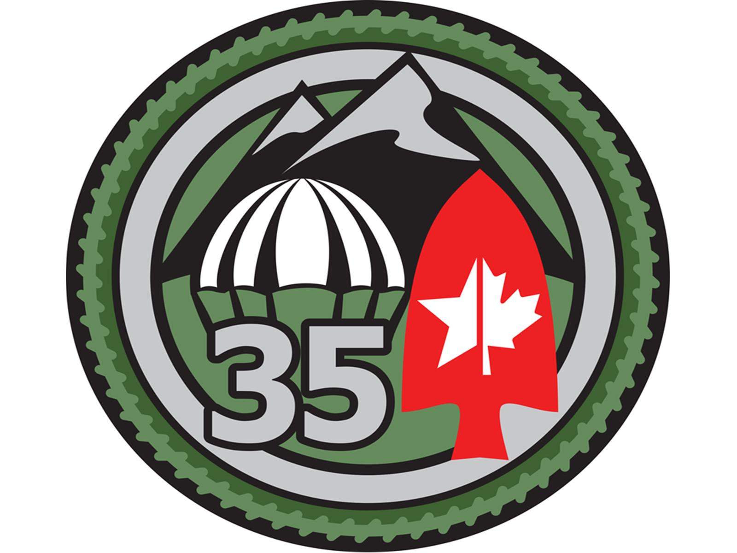
RLA JUMP SCHOOL / 35th MOB MOUNTAIN SPECIAL PURPOSE TEAM
NORTH BALDWIN, NEW YORK 11510

We require the following information to complete your application to attend the Royal Lao Airborne Jump School (northern region) in Gansevoort, NY. Please print clearly. Unless you specify otherwise, your certificates and orders will include the information you show below.

Name: Click here to enter text. Click here to enter text.
First Middle Last

Address: City State: Zip:
Click here to enter text.

SSN (Last 4 Digits) Cell Phone: Home Phone:
Click here to enter text. Click here to enter text.

Email Address: Date of Jump:

Branch of Service: Rank:

Weight: Can Not Exceed 220 lbs.

*For the table above, simply click where you need to input information and enter information as requested.

CHECK ONE BY CLICKING IN BOX BELOW:

☐ I am not jump qualified and I need five (5) static line jumps. Cost is $200 deposit + $100 per static line jump. Total $700.00. This includes 5 static line jumps, ground school training, all jump equipment and gear, and US Parachute Association Liability Insurance, (USPA Insurance is good for 90 days. After 90 days, you will have to repurchase USPA Insurance, by the year, if you wish to maintain coverage).
☐ I am jump qualified and only need one jump to earn the Royal Lao Airborne Wings. My logbook shows that I have performed a static line or freefall jump within the last thirty 30-days. I will present my logbook to drop zone officials on arrival. Cost is $50 deposit + $100.00 per jump. Total $150. This includes one (1) static line jump and all jump equipment and gear. If you do not have US Parachute Association Liability Insurance you may purchase on site. If, however, you chose not to purchase the insurance you jump at your own risk.

HQ, RLA JUMP SCHOOL / 35th MOB MOUNTAIN SPECIAL PURPOSE TEAM 2

SUBJECT: Application for RLA Jump School, Northern Region

☐ I am jump qualified and only need one jump to earn the Royal Lao Airborne Wings. My logbook shows that I have not performed a static line or freefall jump within the last thirty 30-days. I will present my logbook to drop zone officials on arrival. Cost is $200 deposit + $100.00 per jump. This includes one (1) static line jump, ground school (refresher) training, all jump equipment and gear, and US Parachute Association Liability Insurance, (USPA Insurance is good for 90 days. After 90 days, you will have to Repurchase USPA Insurance, by the year, if you wish to maintain coverage).

☐ I am jump qualified and only need one jump to earn the (foreign wings specified when available). My logbook shows that I have performed a static line or freefall jump within the last thirty 30-days. I will present my logbook to drop zone officials on arrival. Cost is $50 deposit + $100.00 per jump + foreign wing cost. This includes one (1) static line jump and all jump equipment and gear. If you do not have US Parachute Association Liability Insurance you may purchase on site. If, however, you chose not to purchase the insurance you jump at your own risk.

☐ I am jump qualified and only need one jump to earn the (foreign wings specified when available). My logbook shows that I have not performed a static line or freefall jump within the last thirty 30-days. I will present my logbook to drop zone officials on arrival. Cost is $200 deposit + 100.00 per jump + foreign wing cost. This includes one (1) static line jump, ground school (refresher) training, all jump equipment and gear, and US Parachute Association Liability Insurance, (USPA Insurance is good for 90 days. After 90 days, you will have to repurchase USPA Insurance, by the year, if you wish to maintain coverage).

- To enroll in the RLA Basic Jump Training program, you must pay in advance a $200 non-refundable deposit.

- REMEMBER – Jumpers performing one jump to qualify for RLA or foreign wings, and who have performed a static line or freefall jump within the last 30-days, must pay in advance a $50 non-refundable deposit. Jumpers performing one jump for RLA or foreign wing qualification, and who have not performed a static line or freefall jump within the last 30-days, must pay in advance a $200 non-refundable deposit.

- Whether you wish to participate in the complete basic, 5-jump program or merely wish to make one jump, send your respective deposits using PayPal to specialini@aol.com – or by sending a check or money order to the following address:

COL James E. Fischer
889 Edward Street
North Baldwin, NY 11510

Make check or money order payable to COL James E. Fischer, and in the memo portion of your check or money order write RLA Airborne, NY.

HQ, RLA JUMP SCHOOL / 35th MOB MOUNTAIN SPECIAL PURPOSE TEAM 3

SUBJECT: Application for RLA Jump School, Northern Region

- When you show up for Jump School, you will pay $100 per jump prior to making each jump - either by CASH or CREDIT CARD. Upon completion of your training, which will likely be late Sunday afternoon (if not sooner), a Pinning Ceremony will take place, and you will receive your jump wings, a set of orders, a certificate in English and a certificate in Lao, a challenge coin, and a log book.

- Forward the completed forms (application & medical), by email or regular mail. If you choose regular mail send forms and respective deposit to COL Fischer at the above address. If you send application and medical forms via email you must immediately follow-up by either submitting your deposit via PayPal or by way of a check or money order in regular mail. REMEMBER: If you submit/send only your application and medical forms you will not be inserted into a training slot until the arrival of your deposit.

- During ground school, you will have to demonstrate a competency in speaking English and understanding English. If you are unable to do so, you will not be permitted to participate in the jump class nor jump.

- If an RLA member / ROTC cadet / other visiting military associate / civilian jumper, etc., under the sponsorship of/by the RLA, is removed from training for disciplinary issues, unsafe acts, or other factors relating to an inability to fulfill qualification training and jumps, that person will forfeit his/her initial deposit.

- There is no jumper age limit. However, if trainee demonstrates an inability to perform the
called for safety and/or deployment measures (lack of dexterity, reflex, memory), or in some
other way shows an inability to physically meet aircraft exit, descent or landing technique
expectations, Skydive Saratoga and/or the RLA reserves the right to eliminate trainee from
the program.

James E. Fischer, Ph. D.
COL, Infantry
Commandant, RLA Jump School, Northern Region

USPA Member: 255514
USPA License: B-24956

PayPal: specialini@aol.com
Primary Email Contact: commofschoolsrla@aol.com

 | Kingdom of Laos  Royal Lao Airborne  RLA Jump School / 35th MOB Mountain Special Purpose Team  North Baldwin, New York 11510 | 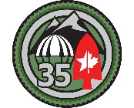
MEDICAL CONDITION FORM
The purpose of this form is to provide our Jump School medical personnel with information on any
existing medical conditions you may have or had and will not be shared with anyone else.
DATE: ______________
NAME: ________________________ _____________________________
Last first
EMERGENCY CONTACT PERSON: ________________________ ______________________
Last first
___________________________________ ____________________________________________
Phone w/area code relationship
1. Have you ever had a seizure? Yes ( ) No ( ) If yes, in the past 10 years? Yes ( ) No ( )
2. Do you have any Allergies or had Allergic Reactions? Yes ( ) No ( ) If yes, please list:
______________________________________________________________________________
______________________________________________________________________________
3. Are you currently taking any medication(s)? No ( ) Yes ( ) If yes, what medications & dosages?
______________________________________________________________________________
______________________________________________________________________________
4. Have you had any “flu like” symptoms in the past 72 hours? Yes ( ) No ( )
5. Have you had any major surgeries or significant injuries? No ( ) Yes ( ) If yes, please list:
_____________________________________________________________________________
_____________________________________________________________________________

HQ, RLA JUMP SCHOOL / 35th MOB MOUNTAIN SPECIAL PURPOSE TEAM 2
SUBJECT: Medical Condition Form for RLA Jump School, Northern Region

6. FEMALES ONLY. Have you been pregnant or delivered, or had a pregnancy terminated within
the past 180 days? Yes ( ) No ( )
7. OTHER RELEVANT INFORMATION. Please share any medical information not covered in the
above questionnaire, but that you believe is pertinent to the training you are about to undertake:
______________________________________________________________________________
______________________________________________________________________________

